Snow Shoe Senior Resource Center November 2025
Center Manager: Kelly Stocks Email: snowshoecenter@gmail.com Call or Text: 814.387.4086
Monday | Tuesday | Wednesday | Thursday | Friday
3 | 4  Coffee & Snacks  Rummikub/Cards  11-Medicare open enrollment  11:30-Lunch | 5 | 6  Coffee & Snacks  Rummikub/Cards  11:30 Lunch  Veteran’s Day Trivia | 7
10 | 11  Veteran’s Day  Centers Closed   | 12 | 13  Coffee and Snacks  Rummikub/Cards  11-Hospice care  11:30 Lunch  Bingo | 14  Coffee & Snacks  Rummikub/Cards  11:30 Lunch  Pot Luck or Pizza
17 | 18  Coffee & Snacks  Rummikub/Cards  11:30 Lunch  Turkey Games | 19 | 20  Thanksgiving Dinner at the Bellefonte Elks  Deadline to sign up is Nov. 4 Center Closed | 21  9:30-Perkins  11-Job Lots  12:15-Wal Mart Benner Pike
24 | 25  Coffee & Snacks  Rummikub/Cards  11:30 Lunch  Thanksgiving Party | 26 | 27  Happy Thanksgiving  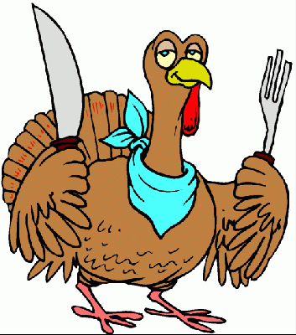 | 28  Centers Closed
Email: snowshoecenter@gmail.com Calendars and menu available: www.supportccscc.org
Calendar subject to change without notice Transportation: 814.355.6807

