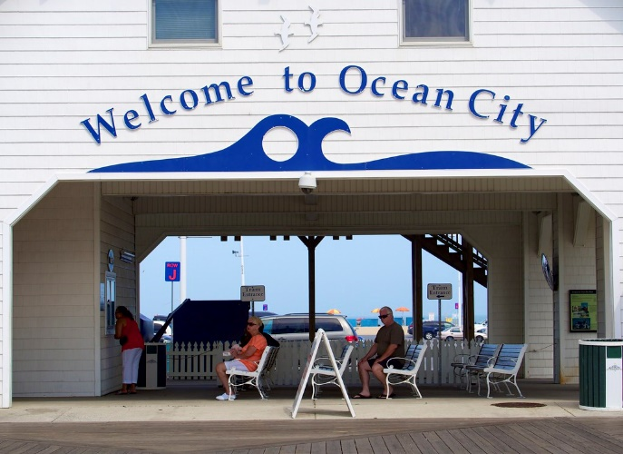

Ocean City Maryland
May 19-23, 2024
$850/pp Double Room. Singles add $165 extra.
- $100 deposit required- Nonrefundable to sign up
- All checks payable to the Snow Shoe Senior Center
- Final payment due no later than April 5, 2024
- Payments can be dropped off at the Bellefonte or Snow Shoe Senior Centers or mailed to:
Snow Shoe Senior Center
P.O. Box 152
Snow Shoe, Pa 16874
- Any questions, contact Kelly Stocks at 814.387.4086 or snowshoecenter@gmail.com
- Trip insurance is available to be purchased separately through Senior Excursions.

